Lab – Managing User Desktops Using Group Policy

Overview

A very common task in any domain environment is to deploy desktop shortcuts (icons) to either all your user’s computers or to a certain group of user’s computers depending on what group(s) the user is a member of. Another common task is setting the wallpaper on all the machines in the domain and restrict users from changing it. Both can be done using Group Policy.

For this tutorial, our environment consists of the following:

* Windows Server 2012, 2016 or 2019 domain controller
* Windows 10 client
* Need a shortcut to Syberoffense.com placed on all desktops

Deploying desktop shortcuts using Windows Server Group Policy

The screenshot below is what we will be accomplishing in this first lab of this tutorial. All computers (and servers) will be getting this new desktop icon shortcut.

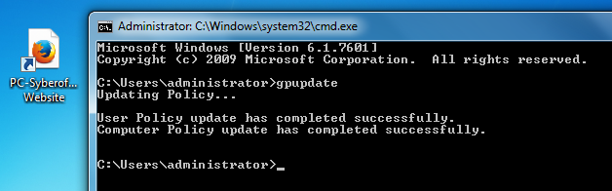

Open Group Policy Management on your Windows Server 2012 box.

* Launch Server Manager
* Click on Tools
* Select Group Policy Management

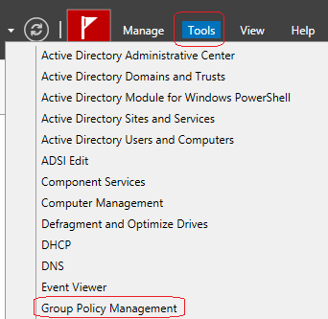

In this example, we want all the users in the domain to have this shortcut.

In the left window pane expand Domains, click on the name of your domain, and expand the Group Policy Objects container. Find the Default Domain Policy, right-click and select Edit.

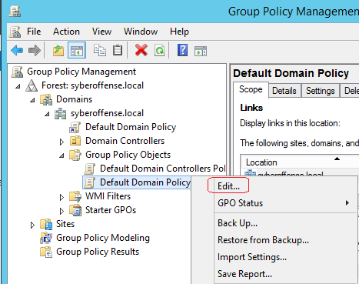

In the Group Policy Management Editor window, expand User Configuration | Preferences and click on Shortcuts.

Right-click in the white empty area, select New and then select Shortcut.

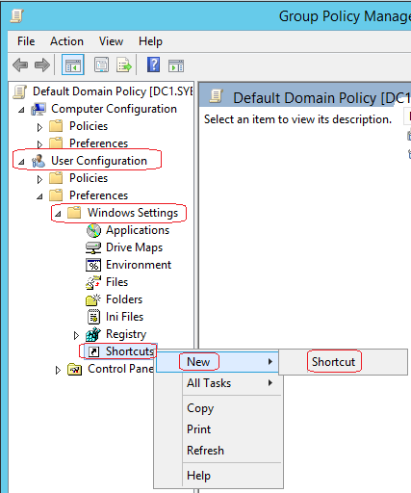

On the General tab, fill in the following:

* Name: PC-Syberoffense.com Website *(this is the name that will show up on the shortcut on the desktops)*
* Target type: URL
* Location: Desktop
* Target URL: http://syberoffense.com

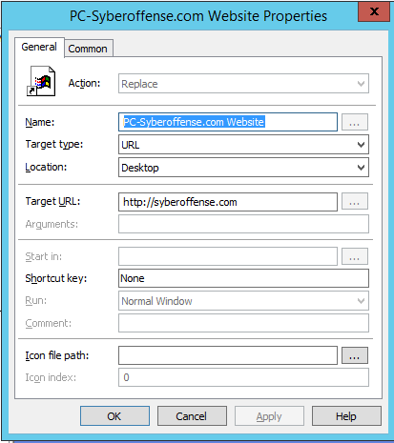

Click on the Common tab.

Select Remove this item when it is no longer applied and select OK to the prompt about changing the Action field to ‘Replace.’

What this will do is remove the icon if we delete this policy, or if the user falls out of the OU structure that has this policy applied to it.

In the Description field, write a short note about the policy. Overtime when you start to have a lot of policies, this can save you a lot of time from having to remember or figure out when and why you set the policy.

In this example, I wrote, **All** users shortcut pointing to web address syberoffense.com. Added 01/09/2018 by Prof. K

Click OK.

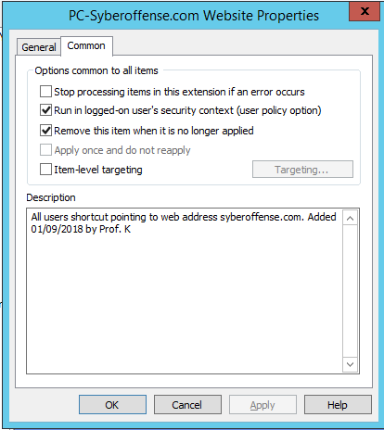

Switch over to your client machine and open a command prompt.

Type gpupdate at the prompt.

After a few seconds, you should now see your new shortcut on your desktop.



Enforce Desktop Wallpaper using Group Policy

If you are working in an organization that has its own logo as a brand, it is likely that the administration of the organization would ask you to do something so that all the computers that the organization has must display the logo and the name of the company on the desktop background. The administration might also ask you to apply such security restrictions so that the end-users cannot change the wallpaper and replace the existing one with one of their own choices whatsoever.  
  
In order to accomplish this, you can use the Windows Server 2012 Group Policy Object and configure the GPO to enforce the image of your choice as the desktop wallpaper on all the computers in the entire domain, or in a particular Organizational Unit.

Log on to the Windows Server 2012 Active Directory domain controller as administrator.

If not already started, initialize the Server Manager window from the bottom left corner of the screen.

On the opened Server Manager window, go to the Tools menu from the menu bar

From the displayed list, click Group Policy Management.

On the opened Group Policy Management console, from the left pane, expand Forest > Domains, and then expand the domain name. (syberoffense.com for this demonstration.).

From the expanded list, right-click the domain name or the target OU that has client computers on which you want to enforce the desktop background wallpaper of your choice.

From the displayed context menu, click Create a GPO in this domain, and Link it here option.

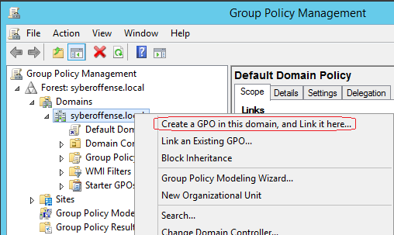

On the opened New GPO box, specify a new name for the GPO in the Name field.

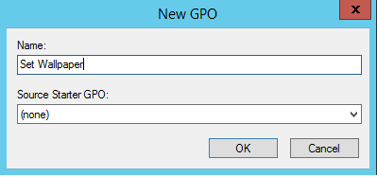

Finally, click OK to create the new GPO and link it to the target domain or OU.

Once this is done, right-click the new GPO.

From the displayed context menu, click Edit.

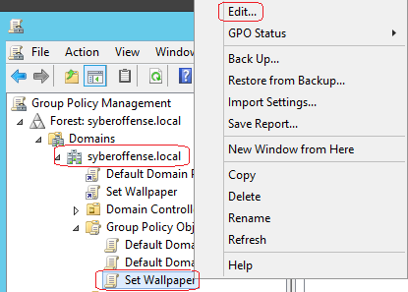

On the opened Group Policy Object Editor snap-in, from the left pane, under the User Configuration section, locate and click to select Policies > Administrative Templates > Desktop > Desktop.

Once selected, from the right pane, double-click the Desktop Wallpaper option.

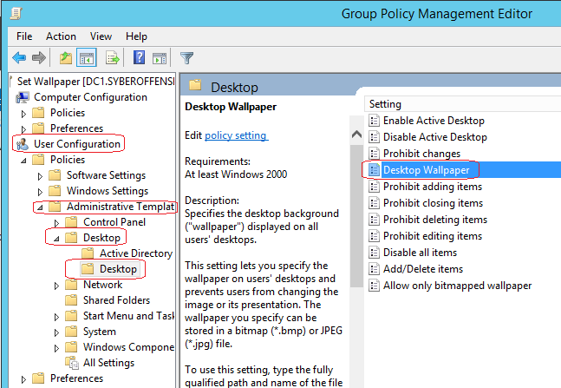

On the opened Desktop Wallpaper box, click to select the Enabled button.

Under the Options section, in the Wallpaper Name field, type a UNC or local path to the JPEG or BMP file that you want to be used as the desktop background wallpaper on all the target computers

For this lab, I created a share at the root of my C: Drive. In the shared folder, I placed the wallpaper image. Remember, the wallpaper image cannot be seen using a local path such as C:\wallpaper\wallpaper. The path used to roll out the image must be a UNC or network path.

For this demonstration, the network path is \\dc1\wallpaper\wallpaper.jpg.

.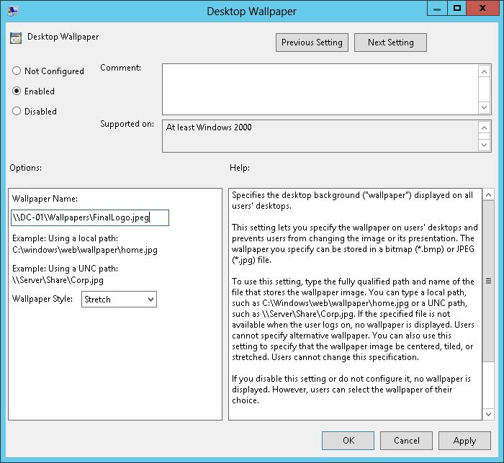

Once done, click OK and back on the previous window, close the Group Policy Object Editor snap-in.

Change over to your Windows 10 client

Press the Windows + R keys simultaneously to initialize the Run command box. In the available field in the Run command box, type the GPUPDATE /FORCE command and press the Enter key to update the group policy settings.

For the wallpaper policy to take effect, a reboot of the client might be necessary. Note the extra time it takes for the client to get to the desktop. This is a behavior of group policy. Each time the machine starts up, it has to go through each GPO pushed out in the domain and configured the settings. The more GPO’s being applied, the longer it takes the user to get a desktop. The same is true when restarting or shutting down the machine. Each GPO setting must be removed one at a time.

Summary –

There are literally hundreds if not thousands of group policy settings that can be pushed out to machine or group in your domain. The trick is knowing which ones to enable. We don’t enable group policy for its sake. Each enabled setting should be based on the needs of the organization.

End of the lab!